Issaquah Robotics Society
2020 Chairman’s Book

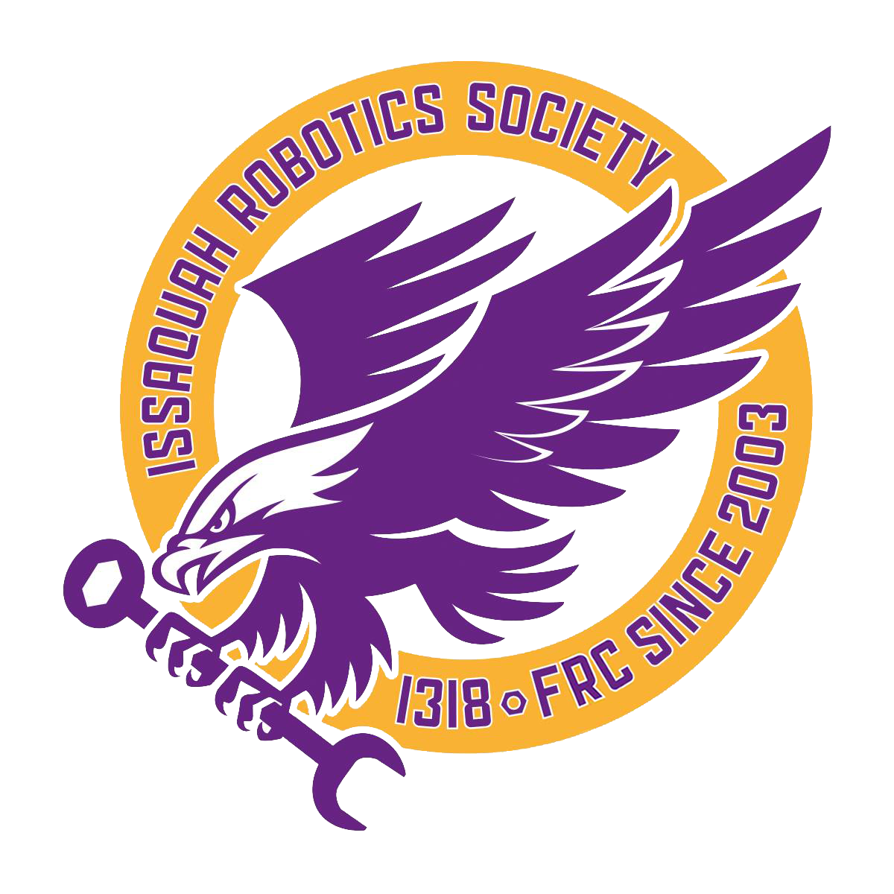

Table of Contents

Chairman’s Questions ---
Participant Impact Page 3
Community Impact Page 3
Innovative Message Page 4
Members as Role Models Page 4
Starting FRC Teams Page 5
Starting FLL Teams Page 5
Assisting Teams Page 5
Mentoring Teams Page 5
Sponsor Descriptions Page 6
Sponsor Partnerships Page 6
Long-Term Impact Page 7
What Is FIRST? Page 7
Other Page 7
Chairman’s Essay Page 8
Fast Facts Page 11

Participant Impact
The impact of FIRST on students is life-long. FIRST provides a direction and outlet for students to pursue their dreams. Life skills such as Gracious Professionalism, leadership, and teamwork are instilled in our members. Our alumni have gone on to places such as MIT, UW, Purdue, and the U.S. Army. One of our alumni attends WPI and is using his FRC skills to compete on BattleBots on national television. 80% of our graduates in the past two years have gone on to study engineering or programming.
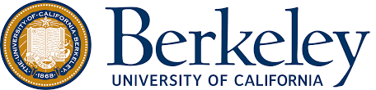
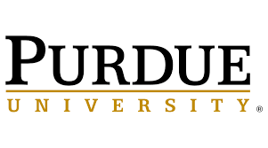
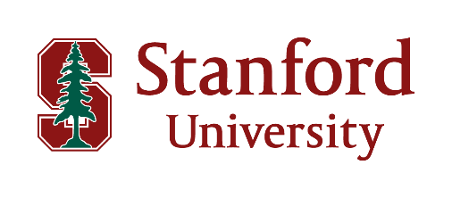
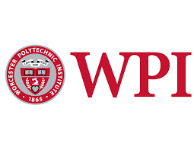
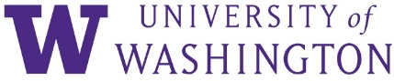
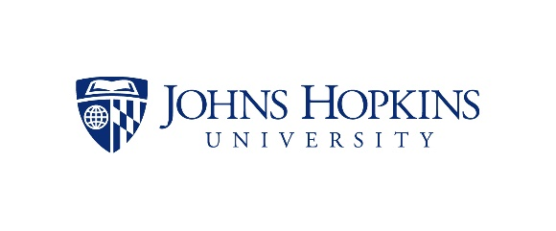
Some Universities that Our Alumni Have Attended:
Community Impact
FIRST has become a well-known STEM program through students in our community who work as leaders to spread information and assistance at volunteer events. We have contributed a total of 1487 volunteer hours in the past year, which includes our outreach events, FLL mentoring, and more. Last March we reached out to the Seattle-based technology news website GeekWire and ended up writing a guest article about FRC, reaching a national audience!
Innovative Message
The IRS spreads the FIRST message with our constant presence at outreach events. One example is our notable presence at the Issaquah Salmon Days festival for the past 11 years, where we have activities and booths that inform the public about FIRST programs. We have informational flyers, small robot-building crafts for kids, and stations where people can drive our robot. We kept track of the number of people who interacted with our booth and found that over 2000 people visited.

Spartabots | FRC 2976
Saints | FRC 1899
Bearded Pineapples | FTC 11104
Escape Velocity | FTC 14343
Gadget Gryphons | FTC 11487
Rose Dragons | FTC 12506
Ender Creators | FLL 39027
LEGO Lassies | FLL 31156
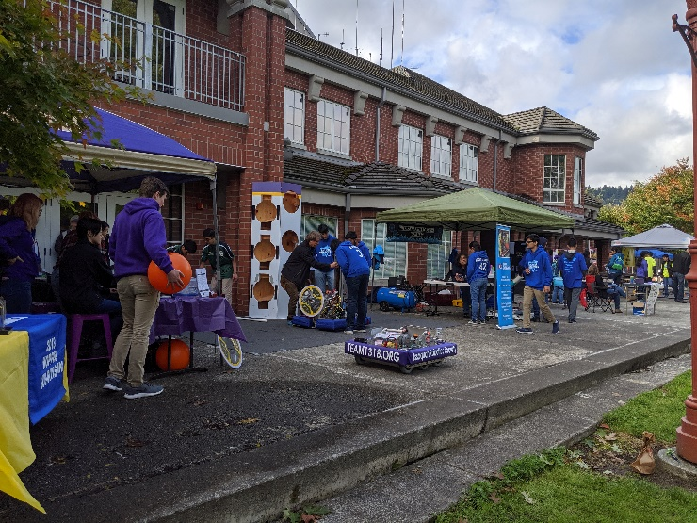
Members as Role Models
Members of IRS are active leaders, working as communicators, event planners and mentors to other FIRST teams. Students help plan our booths at outreach events, and contribute their time at such events. As mentors to FLL teams, we act as leaders to younger FIRST members. Last year, one member created and led a Gracious Professionalism workshop at the SOTAbots workshop, in which numerous other FRC teams participated in a discussion about compassion-focused dialogue in sportsmanship.
Other Teams at Salmon Days:
Starting FRC Teams
One team we have assisted is our rookie sister team, REC 8059, in building their drivetrain and assembling their electronics. As a team that has been around for 17 years, we recognize our responsibility to be a leader to other FRC teams. While we have not directly started an FRC team in recent years, we do our best to share knowledge and resources with rookie teams. We hope to help more teams in the future.
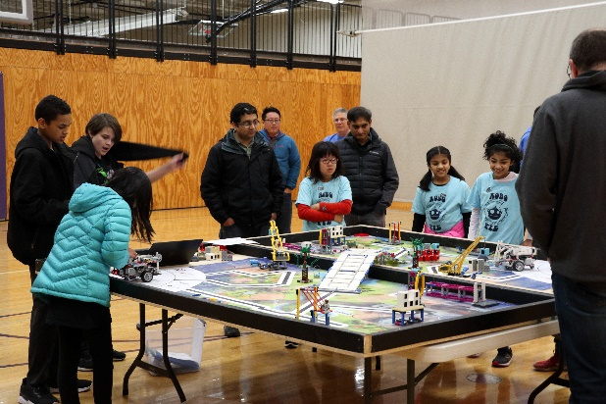
Mentoring Teams
We have dedicated members to mentor 11 FLL teams, many of which were rookie teams with no FIRST experience. Our members consistently volunteered their time every week, totaling 497 hours, each to a team they stayed with throughout the season. They provided technical support as well as leadership and guidance; the kids got to know them not as authority figures but as mentors that genuinely cared about their success.

Our team is dedicated to helping other teams grow and navigate through the FIRST program. We are currently helping newly-made FLL teams progress through the program by providing mentoring. We mentor 11 FLL teams so far, providing technical assistance and guidance. We try to include other teams in our outreach, inviting 2 FLL and 5 FTC teams to join us at the Salmon Days festival. When asked by FIRST WA, we also helped the community by planning and hosting an FLL competition at our school.
Assisting Teams
There are teams that would not have been started if the IRS didn’t provide student mentorship. By FIRST’s definition of starting a team, we did not start any FLL or FLL Jr teams this year, but we supported 4131’s efforts. Our promise to 4131 to ensure the success of those teams through mentoring was essential in their formation. While it was a step in the right direction, we do intend on directly starting FLL teams in the future.
Starting FLL Teams
Sponsor Descriptions
We have a variety of sponsors including Boeing, Microsoft, the WA Superintendent of Public Instruction, the Issaquah Schools Foundation, and our school’s booster club (which usually funds sports teams). The majority of our sponsor funds come from our mentors’ employment matching funds, in which their employers’ donation is proportional to their time spent mentoring us. We thank our sponsors with a signed picture of our team, an invitation to tour our shop, and names on our website and t-shirts.

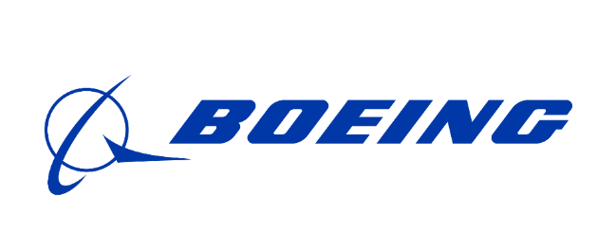
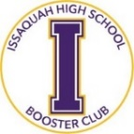
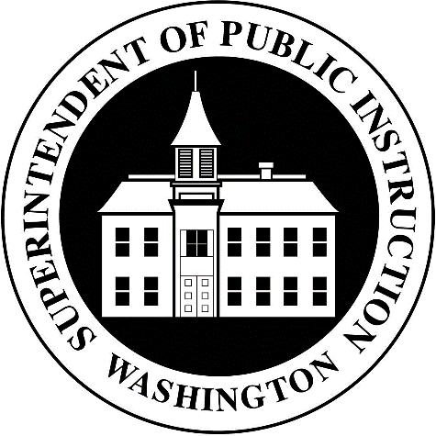
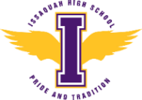
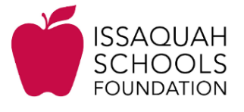
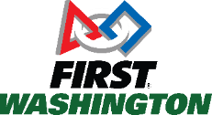
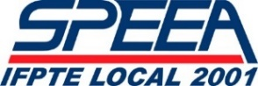
Current Sponsors:
Sponsor Partnerships
We understand the importance of our sponsors and work to maintain active and engaged relationships. Our sponsors are organized into tiers to thank them in proportion to their contributions. This year, we hosted a sponsor open house for both our sponsors and potential sponsors to learn more about our team. Sponsors are also invited to an annual tour of our shop where they can directly see the impact they’ve made.

Long-Term Impact
The IRS has had 17 years to make an impact. With our “Taking FIRST to the Streets” motto, we brought FIRST to community festivals that usually don’t have a STEM presence. These included art walks, farmers’ markets, and the Salmon Days festival. Additionally, one of our biggest accomplishments was in 2008 when we reached out to our state legislature and led a campaign to increase government funding for rookie FIRST teams, funding which is still used to this day.

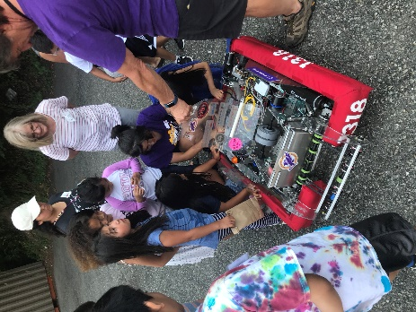
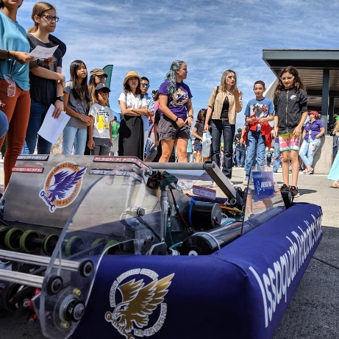
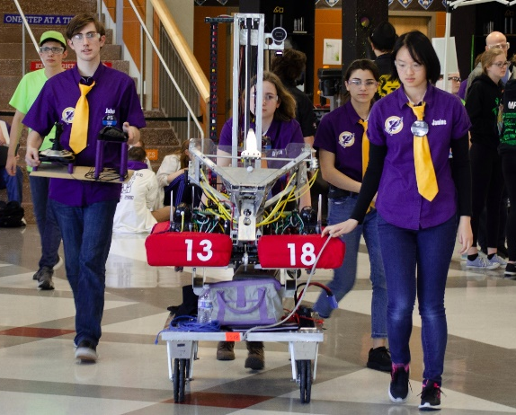
Other
We have a large presence in our community because of our consistent outreach. We continuously show up to events like art walks, science fairs, and smaller festivals like Highlands Days and the 4th of July parade. We collaborated with our local library the past two summers to host fun STEM events for kids, including reading events for under-served communities and creative LEGO building free time. While these events aren’t as flashy, consistency is what makes us a notable part of our community.
What is FIRST ?

Most school clubs model real-world organizations. We like to say that FRC teams model tech startups, in that they prepare their participants for a modern work environment. Team members primarily design, build, and program a technological final product, but others work behind the scenes on fundraising, marketing, data analysis, media production, and charitable work. FIRST is “more than robots” because it teaches every skill you might need to succeed in the tech industry.

Chairman’s Essay

17 years ago, parents at Issaquah High School felt compelled to start an FRC team, kicking off 17 years of robot building, competition attendance, and community involvement. After early outreach success, we thought that implementing the same outreach initiatives every year was enough. After ten years of promoting our 2008 government campaign, presence at festivals, and large team size, we realized that it wasn’t enough. Last year’s Chairman’s judges gave us some advice: while our outreach was sufficient, our year-to-year improvement was nearly nonexistent. The IRS is one of the oldest and largest teams in Washington State, with plenty of resources and accomplishments under our belt, yet we have struggled to extend those resources to others. Taking the judges’ advice, we have worked to give opportunities and experience to others in our community. We have sought out and created opportunities to expand what we do. In the last two years, we have taken that opportunity to improve our impact, regardless of how it affects our ability to win at competitions.

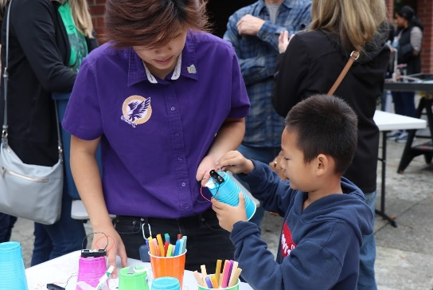
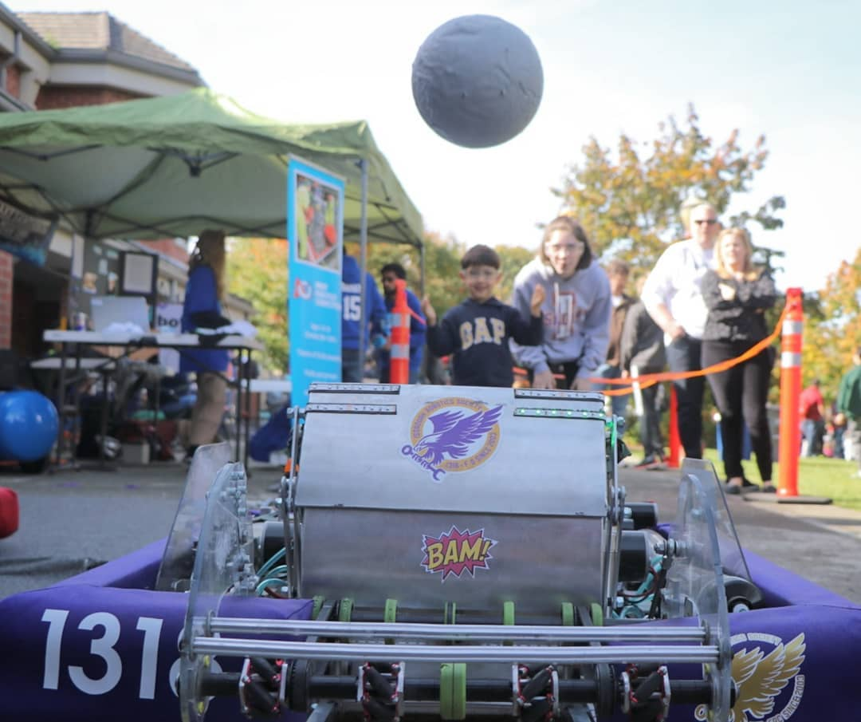
One of our team's main goals is to improve our efforts to introduce new people to FIRST. We do this every year at the Salmon Days festival, which is the largest street festival in Washington State, attracting around 180,000 people annually. Over the 11 years we’ve attended the festival, we have continued to build up a strong presence at the event. Our team was even on the official map! After realizing that we had more than enough resources to run a booth larger than just our team, we took the initiative to talk to the Issaquah Chamber of Commerce. After a few visits, we were able to secure a large patio space that could accommodate the three FRC, five FTC, and two FLL teams that participated. On our patio, you would have been immediately greeted by Gimli, our outreach robot. He scooted around the patio launching a ball to anyone curious about robotics, kids and adults alike. With the extra space, FTC students were able to run mini competitions and FLL students presented their innovation projects to interested families. We handed out flyers with information on each program to passerby, and so many people wanted flyers that we ran out! In preparation for the festival, we soldered over 200 motors for what we affectionately call ‘Wobblebots,’ an arts-and-crafts project for kids to build with plastic cups, markers, and motors. Kids had the opportunity to build their very own tiny robots and learn basic STEM skills. By making an effort to improve our booth, we involved multiple levels of FIRST and showcased opportunities for students of all ages to the thousands of people that came to our booth.

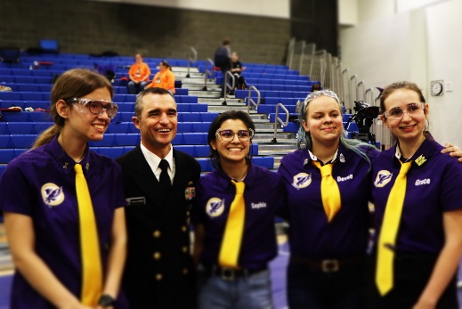
Our team finds a lot of value in bringing FIRST to unconventional places, which is why we’ve worked so hard to extend our outreach beyond just our local community. One of our mentors, a former Naval officer, often remarks that the Navy and other military branches should have a stronger presence in FIRST. A military presence at these competitions allows FIRST students to see opportunities in STEM fields that aren’t as widely advertised as the traditional 4-year university track that many students may find hard to financially achieve. For the past four years we have had a loose connection with the Navy. This last year, we took steps to improve that relationship. What started off with base tours has evolved into invitations to FRC competitions and a presentation at the Navy Recruiting Center in Seattle. We even went so far as to invite Rear Admiral Douglass Perry to be a guest speaker at the Washington Girls’ Generation competition. Through our connections we were able to get enough support to give a presentation about FIRST to the Navy Recruiting Center, where they expressed interest in volunteering at future FIRST events.

Our unconventional network spans from the military to state legislators. We introduced our local government to FIRST when we reached out to U.S. Representative Kim Schrier. Initially, we contacted her to talk about the Christa McAuliffe bill, but it evolved into an opportunity to spread awareness of FIRST. We sent three members of our team to meet at her office with our team’s engineering notebooks, and she was thrilled to learn about what we do. In fact, when we brought up FIRST Ambassadorship, she seemed more than interested and asked for further information. Since 2008, we haven’t worked with our local government to raise awareness of FIRST, and this year we worked to get re-involved.

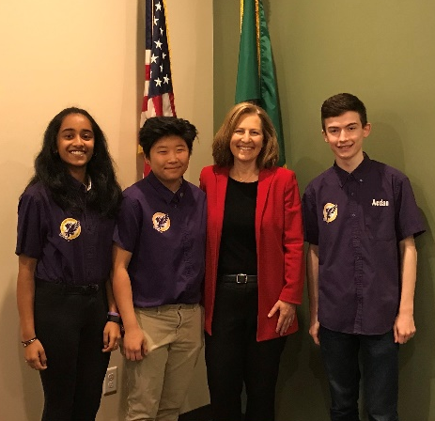
In the midst of the 2019 build season, we hosted a sponsor open house where we invited several Issaquah’s mayor, US Navy servicemen, members of the school board, and potential sponsors to learn more about FIRST and the IRS. After giving an overview of FIRST with a brief presentation, the guests went through interactive sub-team demonstrations. They learned about what our team members do and were able to see the direct impact FIRST makes on our lives. At the end of the event, we let each of the guests take turns driving Gimli, and unsurprisingly, the Naval aviator was a natural! This was the first time our team pulled off an event like this, and we are excited to continue in the future. Our work to expand and strengthen our network presents FIRST and its programs to every aspect of the community.

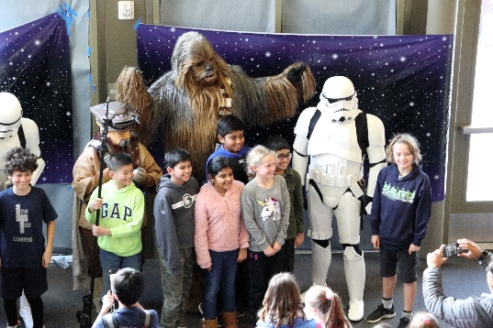
After the last year’s Chairman’s presentations, it became clear that the judges wanted to see our team take real steps in working with other levels of FIRST; we not only needed to create a plan, but put it into action. Our three chairman’s presenters would walk out of the judge’s room with one question stuck in their minds: “Why hasn’t the IRS done more for younger levels of FIRST?” We have been a team for 17 years, and we realized we didn’t have an excuse. A mentor from team 4131 created 10 FLL teams in our local elementary schools, under the promise that 1318 would provide mentorship. With their help, we have become regular mentors to 11 FLL teams this year. Over the course of the FLL build season, our members dedicated a whopping 497 hours to mentoring. Before the end of the FLL build season, we agreed to host an FLL competition at our high school, which was not only an amazing opportunity for us to develop leadership skills, but also a way for our team to support local FLL teams in a tangible way. We had never hosted an event this large before, and honestly, it was a bit daunting. 35 FLL teams were expected, which meant around 800 attendees. We transformed our gyms into action-packed FLL arenas, our physics classrooms into judging rooms where kids showed off their projects, and our lunchroom had suddenly become the pits. To make the event even better, we arranged for the 551st legion, Star Wars cosplayers, to show up and interact with the teams. It was hard to tell whether the kids or the adults were more excited! Volunteers from our team filled every role from MC to judge to referee, spent numerous hours before and after helping with setup and teardown. More importantly, we were able to spend a whole day helping FLL students
create great memories, unforgettable experiences, and learn STEM skills. By the end, our members had put in a combined 434 hours of planning and executing. The positive comments that we received following the event proved to us that we are capable of significant improvement, going from zero to 931 total FLL outreach hours. Though it may be tempting to only focus on our strengths, the process of improving requires us to reflect upon weaknesses and take action to build upon ourselves and push beyond our comfort zone in order to grow and be the best we can be.

These last two years we have reached out within our FIRST association more than ever. We have expanded the familiarity of the program and interest in STEM, with the plan and framework of doing so for years to come. With the continuation of creative, interactive, and integrated outreach, along with communication with our community leaders we work to improve our team every way we can, every year.

Fast Facts

Year Founded: 2003
Team Size: 76 students, 16 mentors
Sponsors: 13
Cumulative Volunteer Hours: 1487

Issaquah Salmon Days Festival
- October 5 & 6, 2019
- Over 2500 visitors to our booth
- 9 other teams joined us
  - FLL 41353
  - FLL 26070
  - FTC 14343
  - FTC 12506
  - FTC 11487
  - FTC 11104
  - FTC 16643
  - FRC 1899
  - FRC 2976

GeekWire Article
- Published April 6, 2019
- Over 1100 Facebook shares

Issaquah Library Events
- August 14, 2019 – “Building Buddies”
- August 14, 2019 – May Valley Reading
- August 15, 2019 – Reading Program

Naval Recruiting Center presentation
- January 13, 2020
- 5 Navy servicemen attended

Sponsor Open House
- March 12, 2019
- Guests included
  - Issaquah Mayor
  - IHS Principal
  - 3 Navy Officers

FRC Sister Team
- REC 8059
- Helped with drivetrain and electronics

Navy Guest Speaker
- Washington Girls’ Generation FRC competition
- October 12, 2019
- By Rear Admiral Douglass Perry

Kim Schrier Meeting
- May 25, 2019

Issaquah Fourth of July Festival & Parade
- July 4, 2019

FLL Mentoring
- 497 mentoring hours
- 11 teams
  - Lynx 14014
  - Titanium Turtles 14016
  - Golden Builders 41325
  - Clark Space Needles 41326
  - Lego Army 41327
  - Roboticlaws 48358
  - Roblaze 48355
  - SMVEMJSUM 48354
  - Bobby Builders 48356
  - Iron Cougars 48728
  - Lego Bots 48353

FLL Competition
- December 15, 2019
- 63 planning hours
- 371 event volunteering hours
- 36 teams participating
  - 9 of which we mentored

