Issaquah Robotics Society
2020 Summary Business Plan

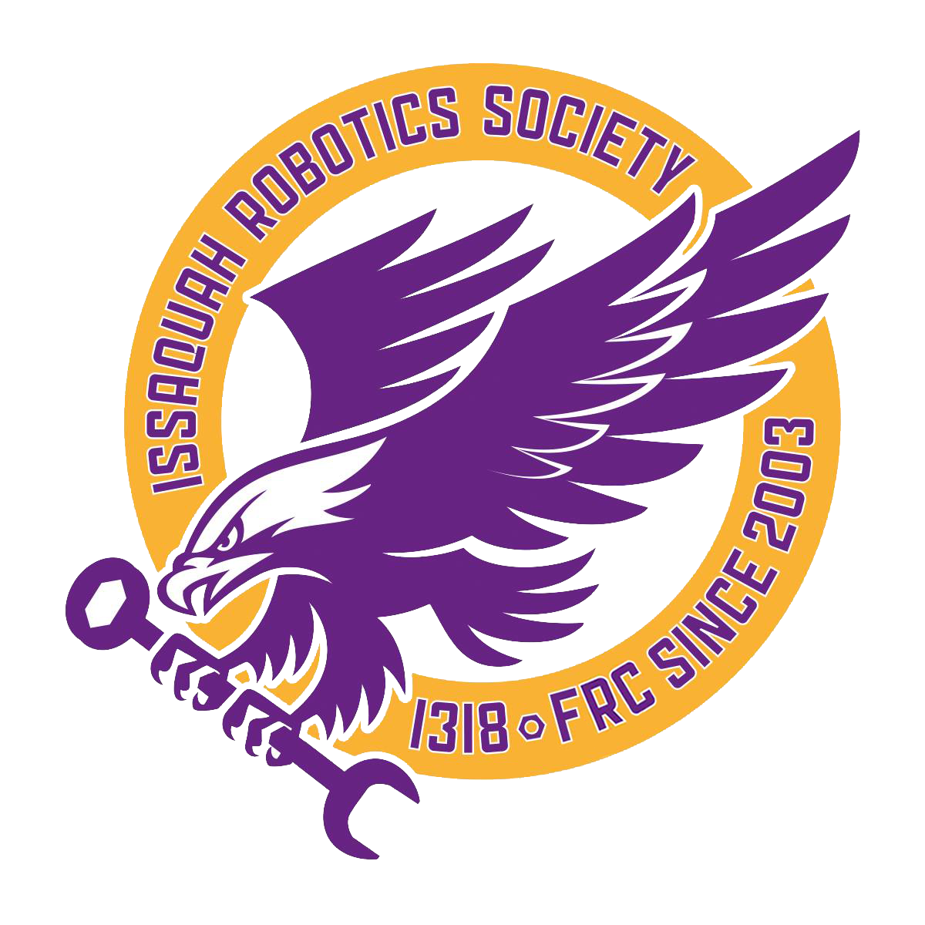

Mission Statement
It is our mission to gain knowledge about STEM through FIRST robotics. Using that knowledge, we spread STEM and the message of FIRST to our local community, creating interest, sustainability, and connectivity.

History & Growth

The IRS was founded in 2003 at Issaquah High School by engineers Tom and Cathy Saxton, with an initial three mentors and eight students. Upon their departure in 2007, the Saxtons transferred leadership of the team to the students. Facing a lack of funding, we developed a business plan and spearheaded a successful campaign to lobby Washington State legislators to provide annual grant funding to FIRST, inspiring new funding sources. The IRS quickly grew in success, attending the FIRST World Championship eight times and earning four district Chairman’s Award wins. Over the past five years, the IRS has exploded in membership. We now boast 76 students and 16 mentors, with 13 major sponsors including Boeing and Microsoft.

Organizational Structure
Day-to-day management is carried out by three student team captains. Their duties include responding to team emails, organizing events, completing administrative processes, and communicating announcements to team members and parents. Captains are typically from the Junior or Sophomore classes to ensure that previous captains remain to pass on their knowledge and skills. Captains are democratically elected every June through a full-team vote.
Our build team is organized into mechanism-based subteams in order to work as a more cohesive unit, each with specific mentors. By having members with various sets of abilities cooperate on a single mechanism of the robot, we create an efficient system that allows us to achieve our goals. Every fall, veteran members train new members in different areas, whether they involve mechanical, electrical, or programming skills, with a pre-planned curriculum. Each subsystem of the robot has a student project manager who facilitates communication with both the captains and other subsystems. These leads are selected by the mentors and captains through a merit-based system.
Our Business subteam manages team operations like marketing, document writing, sponsor relationships, and fundraising. Mentor advisors supervise the use of ASB funds, and expenditure requests are provided to mentors and captains to ensure proper fund allocation.
The scouting subteam is responsible for data collection and analysis. During Build season they design user processes that enhance our strategy. Every fall, they train new rookies in Python and get them acquainted with our scouting system.
The IRS finds new sponsors via public outreach and direct dialoguing with businesses. We make an active effort to involve our community by obtaining local sponsors, as we believe a community with a widespread appreciation for STEM is a major advantage. New members are drawn by posters, robot demonstrations, club fairs, social media, and local media outlets, and we attract new mentors through current students and existing mentors as well as outreach events. Due to the IRS’ proximity to many STEM-based companies, the IRS primarily recruits parents as mentors, but several non-parent mentors discovered the team due to our extensive outreach activities.

Organizational Chart (Appendix A)

Robot Build Subteam

Current Sponsors (Appendix B)

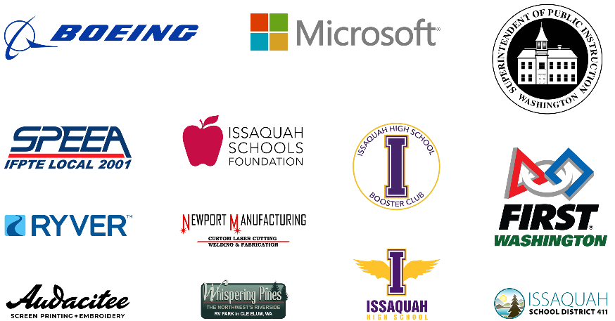

Risk Analysis
The IRS identifies risks and areas for improvement using SWOT (Strengths, Weaknesses, Opportunities, Threats) analysis. This is how it is conducted:

- A full team meeting is held after competition season to recap what occurred and freely discuss the current state of the team’s strengths, weaknesses, opportunities, and threats. This is loosely structured, but notes are taken.
- Supplementary meetings are held afterwards with a small group of student leaders to discuss the team in more detail, create a rough draft of the SWOT analysis, and brainstorm objectives and risk mitigation actions.
- In the following two weeks, the wording of the SWOT analysis is polished and the objectives are confirmed. Actions taken may change over the season depending on the circumstances.
- After build season, student interviews are conducted to analyze the SWOT analysis points. Based on interviews, the status of the objectives are evaluated.
- The evaluation then informs ongoing objectives and the next year’s SWOT analysis.

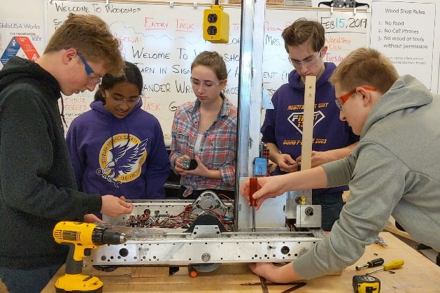
One critical weakness we had observed last year was the lack of communication between subteams. We weren’t as collaborative as we could be, which separated many students from the build process. For example, our electrical subteam had very little involvement in the design of the robot outside of the electronics. One subteam was always waiting for another to finish a part of the robot, meaning some students had to wait around, unable to work. This year, we identified a solution to this problem and created a new organizational structure for our robot build team. We split the robot into subsystems instead of subteams, with each group working on a mechanism on the robot rather than an aspect of it. Each subsystem team had a mix of mechanical students, electrical students, veteran members, rookie members, and mentors. This forced us to be more cohesive, as the subsystems needed to constantly communicate between each other, and each team member had to contribute their own individual expertise. In the end, this new structure not only mitigated our communication weakness, but also our weakness regarding task delegation to rookies.
While planning to mitigate risks is essential, it is also necessary to sustain our strengths. Our biggest strength at the moment is the size and popularity of our team. Our large workforce provides the ability to take on multiple large-scale side projects, such as hosting a FLL competition and organizing a booth at the annual Issaquah Salmon Days festival. These both require many people to plan and participate in, demonstrating the opportunities the size of our team provides. This is sustained through our efforts to make the Issaquah Robotics Society very well known in our school and community by attending outreach events to encourage more students to join the team.

SWOT Analysis at a Glance (Appendix C)
Topic | Associated Objective | Status
Strengths
Large team that includes all grade levels | Sustain a positive public image within our school and community | Met
Long-lasting sponsorships from huge corporations | Sustain relationships with Boeing and Microsoft by providing updates and invitations to events | Met
Cooperation with other teams | Continue to foster good relationships with other teams and invite them to outreach events | Met
17 years of experience | Encourage mentors with long-term team experience to remain involved | Met
Weaknesses
Training is unstructured, which leads to low rookie involvement and retention | Design a comprehensive training and encourage veterans to delegate to rookies and interact with them | Partially Met
Poor time management | Set realistic goals with scheduled action plans to limit procrastination | Unmet
Workspace is often messy and unorganized | Set up systems to clean up workspace and create new organization systems in the summer | Partially Met
Team structure is unorganized and does not give tasks to all members | Detail role responsibilities and restructure build subteams to include more team members | Met
Opportunities
Extra build season time without a “robot bag day” | Utilize extra time for more ambitious projects, while still adhering to deadlines | Unmet
Team-wide interest in restructuring to allow for more complex projects | Reorganize team structure based on member input for more efficient communication and cooperation | Met
New potential sponsors, especially in manufacturing | Reach out to community small businesses to acquire new funds/supplies | Met
New members in the incoming freshman class | Redesign rookie training to create engaged members of the team in their first year | Partially Met
Team-wide interest in beginning to mentor FLL teams | Identify potential mentors, contact/create teams in local schools, set up a schedule | Met
Threats
Sudden canceled meetings from snow days or other random events | Prepare for possibility of canceled meetings by allowing more than enough time to complete projects | Unmet
Travel prices take up a large portion of team funds | Find the lowest possible prices by researching options and connecting with school resources | Met
All team programmers left with the last graduating class | Encourage new members to join the programming subteam and design comprehensive programming training | Met
Lack of “robot bag day” could lead to procrastination of deadlines | Set a build season schedule with specific deadlines, still sticking to the six-week structure of prior years | Unmet
Too many ideas for summer projects to all be manageable | Determine the amount of time needed for each project and cut those that are both most time-consuming and least important | Partially Met

Marketing Analysis

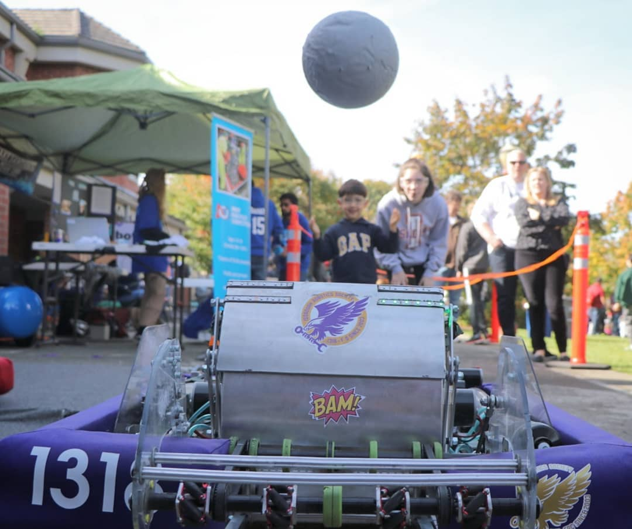
Issaquah is a community that prioritizes learning and provides access to STEM companies, ideal for sponsor and mentor recruitment. Our community provides resources and opportunities for us to spread awareness of FIRST and our team through various avenues of communication. Our presence at community events plays a large role in bringing recognition to our team. We make sure to cater to the interests of many demographics, especially young children. A culmination of these aspects is displayed at our annual booth at Salmon Days, a community festival with over 150,000 attendees where we display and spread awareness of our team. Our team is well known at these community events, with people specifically seeking out our booth. The IRS brand is one of active community involvement in STEM; we want to be seen by others as an organization dedicated to technological progress and the inspiration of STEM. Additionally, our continual presence on social media platforms such as Instagram allows us to achieve recognition from over 1,000 followers.

Financial Analysis
The IRS handles our financials with care. When looking for new sponsors, we contact local businesses and provide them with information about our team through a custom sponsor package. In return for their support, we promise certain branding on our team materials. Last year we began implementing a custom sponsor tiering system, which allows us to reward sponsors based on their contribution. Although the tiering system is not actively used by our sponsors, it provides a solid framework and direction for the organization of our sponsors, aiding our ability to sustain funding.
Looking at our team budget, our income mostly comes from grants from foundations like the Issaquah Schools Foundation, matching donations proportional to mentor’s volunteer hours, and monthly funds from team members. We also hold fundraisers to provide resources for our team. Last season we sold Brown Bear Car Wash coupons to make a profit, which we continued this year, along with a similar fundraiser with Krispy Kreme donut coupons.
Our main expenditures are in the form of robot parts, supplies, and travel expenses. The 2019-2020 budget shows our income and expenditures starting from July 2019 based on out income and expenditures from the 2018-2019 season. We are projecting no decrease to our initial surplus balance of $70,998.49. We focus on the individual income and expense categories to determine what areas can be reduced and where we can increase our total income.
So far in the 2019 to 2020 season, our cash flow is approximately -$56,000 due to pre-booking world championship airfare and hotel expenses. (Analysis of our probability of qualifying for the world championships showed us that buying these in advance will save money in the long run.) However, as the season progresses, we will see an increase in income due to team dues, trip fees, inventory sales and grant funds. This information is shown in the 2019-2020 Budget in Appendix D. Our funds are held in two accounts: one through FIRST Washington and one through our school’s Associated Student Body (ASB).

2019-2020 Budget (Appendix D)

